
CANDIDATE BRIEF
Clinical Lecturer in Restorative Dentistry with Monospeciality Training in Endodontics, Faculty of Medicine and Health

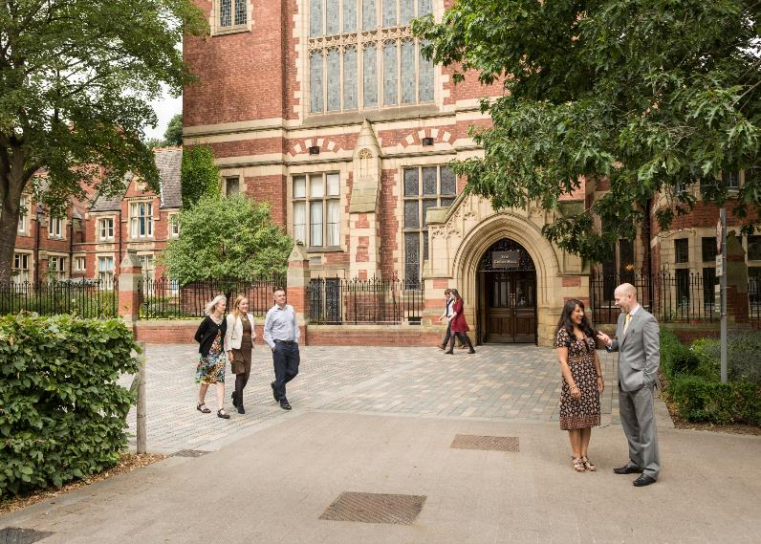
Salary: Clinical Lecturer Salary Scale (without honorary consultant contract), £45,943 - £82,701 p.a., depending upon qualifications and relevant experience.
Reference: MHDEN1287
Closing date: 13 February 2026
Interview date: 30 April 2026

Clinical Lecturer in Restorative Dentistry with Monospeciality Training in Endodontics
School of Dentistry

Are you interested in developing an academic career alongside a role in teaching undergraduate dental students in Restorative Dentistry? Do you want to provide excellence in clinical patient delivery in Endodontics?
We are seeking a highly motivated individual who is passionate about teaching in Restorative dentistry. You will be an individual who wishes to pursue specialist training in Endodontics and to contribute to the development of undergraduate dentists. The post will be split with 50% academic activities and 50% clinical training and is available for up to six years according to the training needs of the candidate. You will be awarded a training contract with the Regional Postgraduate Dean in the specialist registrar/specialty trainee grade (or equivalent) with an honorary contract with the appropriate NHS Trust.

The appointment is subject to being benchmarked through the Restorative Dentistry National Recruitment process (expected to take place in May/June 2026) to ensure candidates are at an appropriate level to undertake clinical training starting in September 2026. The successful completion of the approved training programme will lead to a CCST in Endodontics.

To be eligible to apply for this lectureship, you will have a BChD or BDS degree (or equivalent) and hold full registration with the UK General Dental Council. You will have completed foundation training/relevant general professional training or the equivalent and have developed clinical competencies in Restorative disciplines. Evidence of a commitment and enthusiasm for pursuing an academic career in Restorative Dentistry and commitment to the specialty with clear career objectives are an essential requirement.

What does the role entail?

Academic activities

The role involves participating in undergraduate and potentially postgraduate teaching and supervision in Restorative Dentistry, providing high-quality education and support to students, and managing assessments. Additionally, the role includes contributing to the planning and review of courses, engaging in scholarship and innovative educational approaches, and fulfilling administrative duties within the School, Faculty, and University.

We would expect the successful candidate to take annual leave predominantly outside of University term-time.

You will report to Head of Department and Division of Restorative Dentistry.

Clinical activities (see Appendix for additional information)

The post has approval by the Postgraduate Dean for specialist training leading to a CCST in Endodontics. An NTN will be awarded and training will commence after successful benchmarking through the Restorative Dentistry National Recruitment process to ensure candidates are at an appropriate level to undertake clinical training.
Within Restorative Dentistry, there are out-patient clinics providing services in all aspects of Restorative Dentistry, and comprehensive laboratory facilities are available. Most clinical sessions will be spent in the Department of Restorative Dentistry at Leeds Dental Institute. Treatment sessions within the endodontics along with other areas of restorative dentistry will be carried out throughout the whole tenure of the post, according to a weekly rota. Clinical facilities are excellent.
Excellent clinical experience and training will be gained from participation in a wide variety of Consultant Clinics seeing patients referred by general dental and medical practitioners and Consultant colleagues for a range of specialist advice and treatments under the supervision of the Consultants.

What will you bring to the role?

As a Clinical Lecturer in Restorative Dentistry and Specialist trainee you will have:
- Met the criteria for Restorative Dentistry and mono-specialties ST1 person specification and entry requirements (Restorative Dentistry ST1 person specification | Dental Hub)
- Experience of, or an ambition to be involved in clinical teaching in undergraduate education with evidence of delivering undergraduate or postgraduate teaching, or teaching other Dental Care Professionals;
- Ability to contribute effectively to student education on programmes of study offered by the School of Dentistry;
- A developing record of scholarship activities;
- High level communication and presentation skills in both written and spoken English, including IT skills;

You may also have:
- Fellowship in Dental Surgery or Membership of the Faculty of Dental Surgery or equivalent;
- FHEA accreditation or recognised teaching qualification or currently undertaking training in teaching or willing to work towards;
- Evidence of contributing effectively to the education of students on programmes of study with a proven track record of delivery of the highest quality dental education at undergraduate and / or postgraduate level;
- Evidence of innovative approaches to dental education and assessment in the area of Restorative Dentistry;
- Experience of Quality Assurance and Enhancement in Student Education;

How to apply
You can apply for this role online; more guidance can be found on our How to Apply information page. Applications should be submitted by 23.59 (UK time) on the advertised closing date.

Contact information

To explore the post further or for any queries you may have, please contact:

Professor Nic Hodson, Head of Division of Restorative Dentistry
Tel: +44 (0)113 34 30284
Email: N.A.Hodson@leeds.ac.uk

Hannah Beddis, Consultant in Restorative Dentistry, Training Programme Director for Restorative Dentistry
Email: hannah.beddis@nhs.net

Additional information

Find out more about the Faculty of Medicine and Health

Find out more about the School of Dentistry.

Find out more about Athena Swan in the Faculty.

Working at Leeds
Find out more about the benefits of working at the University and what it is like to live and work in the Leeds area on our Working at Leeds information page.

Candidates with disabilities
Information for candidates with disabilities, impairments or health conditions, including requesting alternative formats, can be found on our Accessibility information page or by getting in touch with us at disclosure@leeds.ac.uk.

Criminal record information

Rehabilitation of Offenders Act 1974 (Exceptions) Order 1975
This post requires an enhanced and barred list criminal record check from the Disclosure and Barring Service (DBS), and any equivalent overseas authorities where relevant. The successful candidate will be required to give consent for the University to check their criminal record status. All applicants are required to make a self-declaration where applicable.

Any offer of appointment will be subject to the University being satisfied with the outcome of these checks, in accordance with our Criminal Records policy. You can find out more about required checks and declarations in our Criminal Records information page.

This may be evidenced by i) undergraduate dental training undertaken in English; or, ii) academic International English Language Testing System (IELTS) results showing a score of at least 7.0 in each domain (speaking, listening, reading, writing), with an overall score of at least 7.5, to be achieved in a single sitting and within 24 months of the time of application; or, iii) alternative supporting evidence of language skills.

